d

TOne Tenants Document

Contents

Document Purpose 2

Diagrams 3

# Document Purpose

The purpose of this document is to discuss the multi-tenants structure in TOne and its impact on each TOne module

# Diagrams

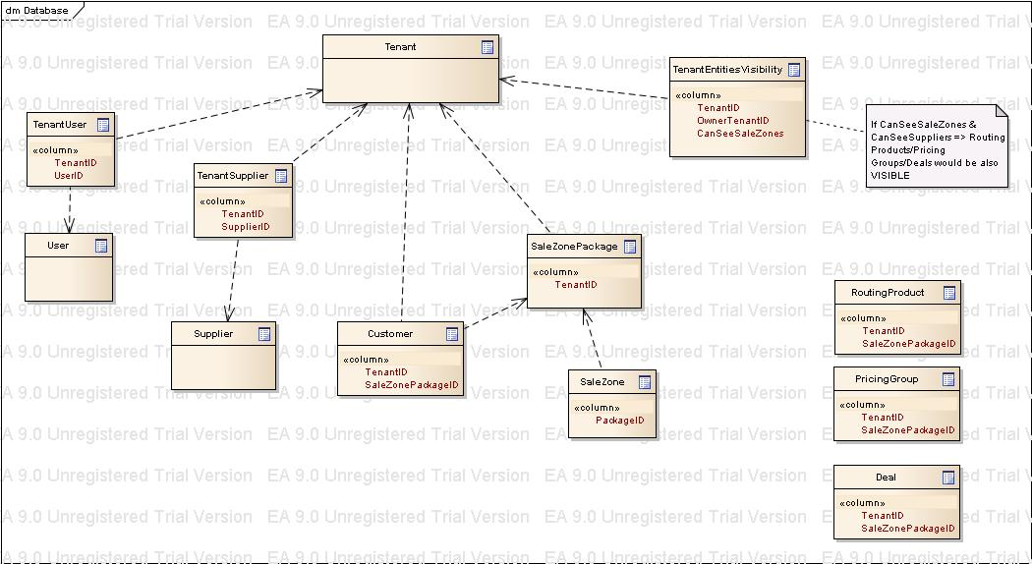

# Impact Analysis

The multitenant structure has impact on the following modules:

|  |  |
| --- | --- |
| Module Name |  |
| Tenant Management |  |
| Business Entities |  |
| Administration (Users/Groups) |  |
| Routing |  |
| Sales Area |  |
| Purchase Area |  |
| NOC Pages |  |
| Billing Module |  |
| Invoices |  |
| BI |  |
| Switches |  |

## Tenant Management

An administrator who has permission on the Tenant, can:

* Create a new tenant
* Edit an existing tenant
* Assign users to tenant

## Business Entities

* Create Supplier

|  |  |  |  |
| --- | --- | --- | --- |
| Module | Page | Tenant Selection | Related Entities Selection |
| Business Entities | Carrier Account Management | Multiple |  |
| Business Entities | Carrier Account Editor | Multiple if Supplier, Single if Customer |  |
| Business Entities | Sale Zone Package | Multiple |  |
| Business Entities | Code Preparation | Single | Select Sale Zone Package |
| Business Entities | Import Price List | Single | Select Supplier |
| Business Entities | Rate Planning | Single | Select Customer |
|  |  |  |  |